TFHQ Mini Game 1: Flankscape

Summary
The Flankscape is a Flanker Task (Eriksen & Eriksen, 1974) that has been adapted to virtual reality. The traditional Flanker task presents users with a set of objects (arrows) and users are instructed to respond to the object presented in the middle of the set, and to ignore shapes that beset the target object. The Flankscape will build on this paradigm by making the arrow objects three-dimensional and moving towards the user is a cohesive game-like environment with alien ships that move around and shoot Flanker stimuli. Participants in the Flankscape will need to self-regulate to respond correctly. Most of the game should look and feel similar to this game (4:12-41) and this game, with some tweaks.
Psychological Justification
The psychological demands of military aviation are extraordinary. In this occupation, brief lapses in attention can be very consequential. They can lead to losses of situation awareness, increased response time, loss of control of the vessel, or lack of coordination with the mission team, ultimately threatening mission success and safety. Thus, military aviators must be extraordinary regulators of their psychological resources. They need to know when to pay close attention, when to follow protocol to a tee, and they need to know how to keep themselves alert and vigilant. Expanding how self-regulation is measured will improve how it is assessed in aviation candidates, thus bolstering warfighter readiness.
For this MPT project, self-regulation is the ability to effortfully and effectively exercise executive control over one’s psychological resources. There is an infinitude of ways to “demonstrate” self-regulation. I self-regulate daily after the gym by not ordering Napolis pizza and choosing to go home and cook chicken breast. But the Navy would not like tempting it’s candidates with pizza, so the Flankscape will employ a more traditional task.
A traditional test of self-regulation is the Flanker Task (Eriksen & Eriksen, 1974). The Flanker combines targets (an arrow in the middle of the screen) with distractors (arrows presented at the same time of the target, flanking it on both sides). Performance is defined by response that aligns with the target, not the distractors. So, the correct way to respond to the stimuli presented in Figure 1 would be to press the right arrow. In essence, this task requires the user to sustain attention across trials and inhibit (regulate) the urge to click the wrong response.

Figure 1
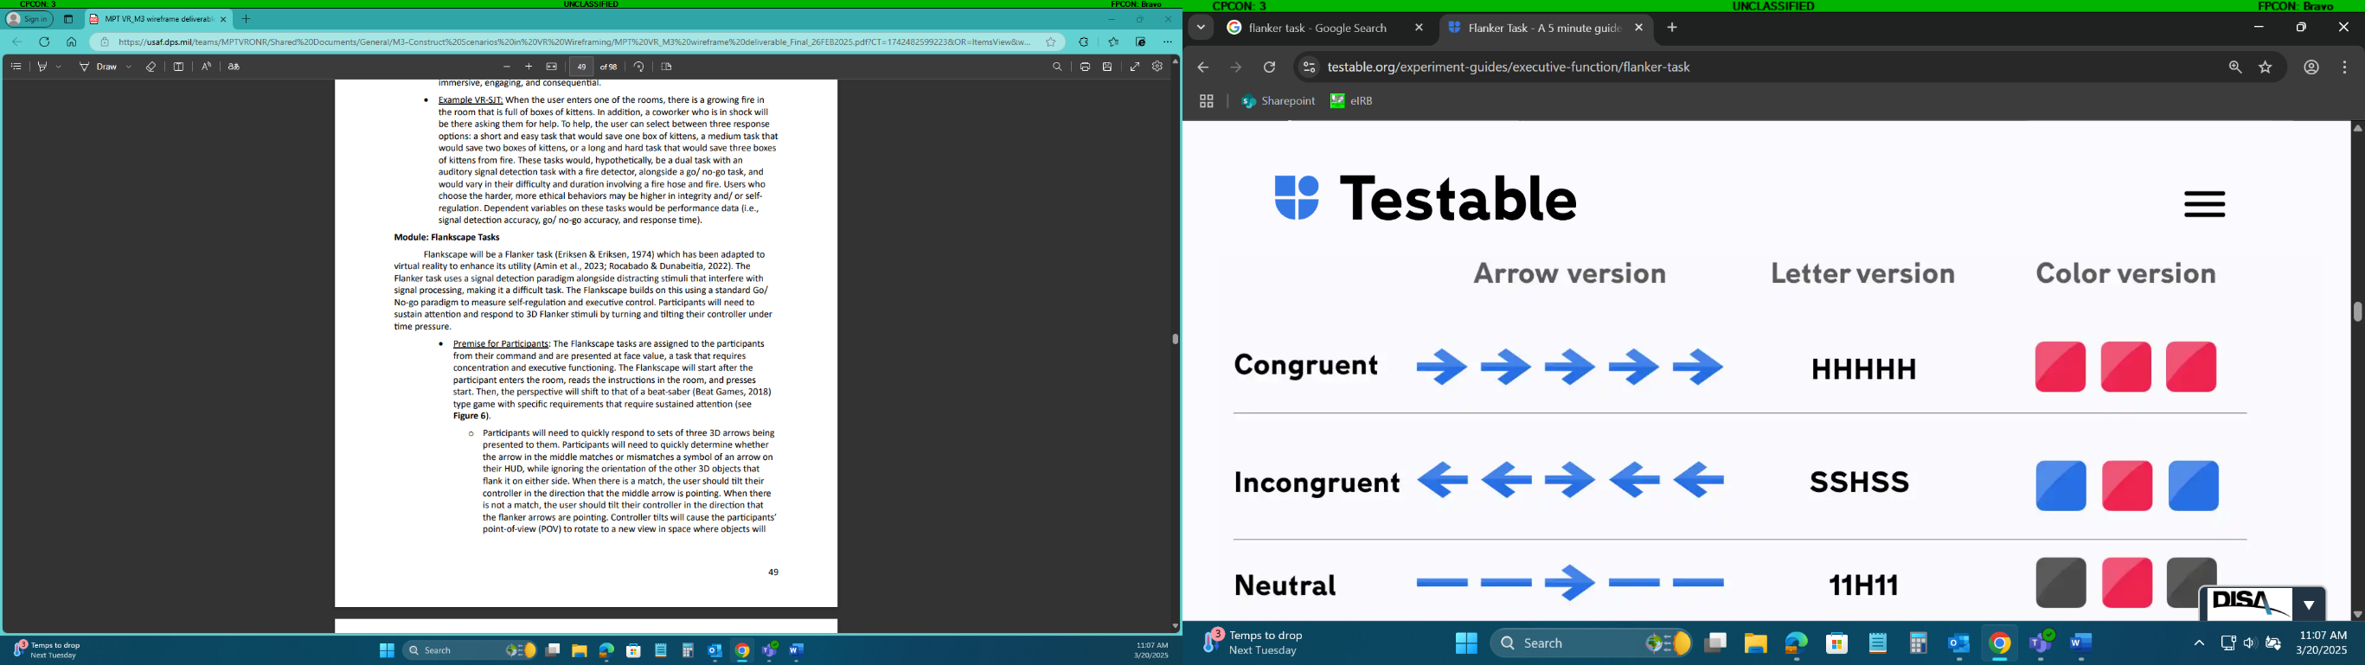
Flankscape Arrow Objects Flow
The main purpose of the Flankscape is to test self-regulation by creating a task that requires sustained attention, rule following, and inhibition. The Flankscape is designed to take the Flanker task and put it in a cohesive and immersive VR environment. At its core, the Flankscape is a Flanker task with 3D arrow objects in a 3D environment; not 2D arrow objects presented on a flat screen. The greater environment should look similar to this game (4:12-41) and this game.
The arrow objects will appear in groups of three: A target object in the middle, and distractor objects to its right and left. The three objects will all be next to each other in one row; not staggered behind each other (see Figure 2 for a visual). The next set won’t appear until after the user responds.
The presentation of the Flankscape stimuli (arrow objects) should feel fast-paced and unpredictable. Arrow objects will be shot at the user from a hostile alien ship that moves as it shoots (more on this later). The alien ship will be far away, maybe 100-400m, so that the arrow objects are not readable/ visible/ clear until they are close to the POV. The arrow objects should take about 4 seconds to be shot – from the time they leave the alien ship to the time they would “hit” or collide with the user’s POV/ ship. Also, the arrow objects should be presented at inconsistent intervals. Sometimes the next ones will shoot at you immediately after a response, whereas other times it will be a multiple second wait. The “delay” should feel unpredictable, though it does not need to be literally random.
The arrow objects should look 3D and clearly discernable/ clear. In the linked videos above, I like that the edges of the objects are a different color than the filling color of the object, and that they are high contrast from the rest of the environment. I don’t have a preference on their color, but they should stand out from the background. The arrows will always be pointed right or left, not up or down or diagonal or any other direction.

Figure 2
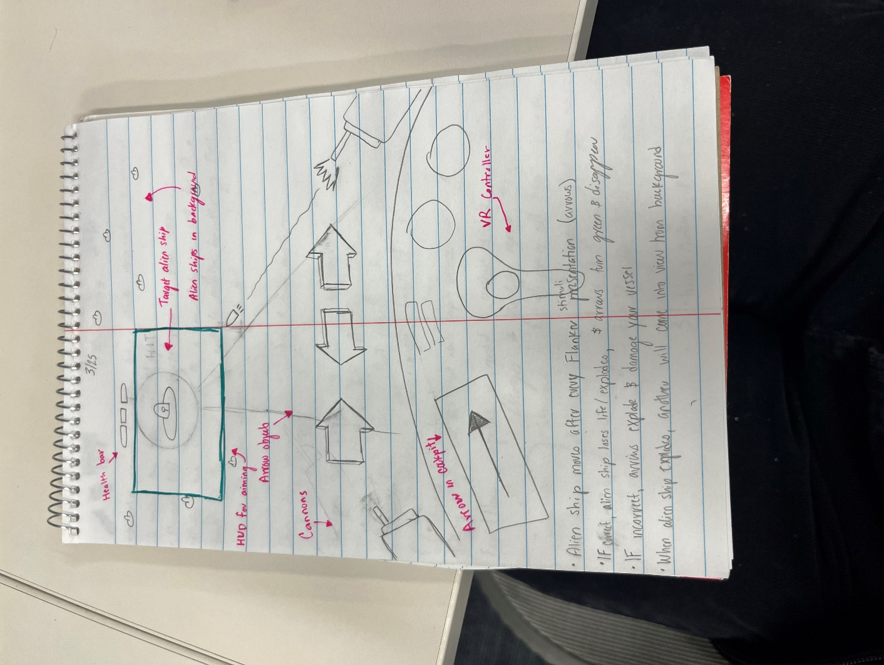
Distribution of Arrow Objects
Every set will have a different combination of arrow objects pointing either left or right. The distractor arrows will always point the same direction as each other but they will only point in the same direction of the target arrows 50% of the time.
There should also be a 2D arrow symbol on the cockpit display. It will change directions/ ways it is pointing. The color of this arrow symbol should be close to/ the same as the color of the arrow objects. The directions of the target arrow object, the distractor arrow objects, and the cockpit arrow symbol will be orthogonal and uncorrelated, thus creating the inclusion proportions specified in Table 1.
Table 1
Flankscape Arrows | Cockpit Arrow | Percent inclusion
 |  | 12.5%
 |  | 12.5%
 |  | 12.5%
 |  | 12.5%
 |  | 12.5%
 |  | 12.5%
 |  | 12.5%
 |  | 12.5%
**Cait and I did a pretty extensive logic table with these arrows and these are the proportions that are best. You may notice after development that it looks like different arrow patterns correlate >50% with how to respond correctly, but that is an artifact of right/ wrong way to respond being logically tied. The software will need to calculate % correct based on these rules and record correct/ incorrect responses in the output.
Interplay in Environment
Information on the cockpit display determines whether responses should be based on the target arrow object or on the distractor arrow objects. When the cockpit arrow matches (points in the same direction as) the target arrow, participants will click the right/ left button on their controller that is in the direction of the target arrow. When the cockpit arrow mismatches (points in the opposite direction as) the target arrow, participants will respond in the direction of the distractor arrows. Response selection is defined by clicking right/ left on the VR controller.
Flankscape Arrow + Alien Movement
This next part is hard to explain so bear with me. In the 4 seconds that it takes the alien ship to shoot the arrow objects at the POV, the alien ship can continue to move. The location of the alien ship will determine what angle the arrow objects come from. So, for example, if the alien ship shoots the arrow objects at you from the center of the screen and then moves 20 degrees to the right, the arrow objects will also shift 20 degrees to the right as they approach you, making their path curvilinear. This will incentivize the user to follow the alien ship as it moves in space.
The user will have a box on their HUD that is used for target identification and aiming. It will be fairly big, at least double the size of an alien ship (see below). When the user will need to keep the alien ship within this box so that the user’s cannons have a target identified and can fire at the alien ship when they respond correctly (more on this later). When the alien ship is within the box, it will be green. When the alien ship is outside the box, it will be red. The cannons will only be able to fire when the target is identified (green box) and the correct response (right/ left) is selected. See Figure 3 for a visual.
Figure 3
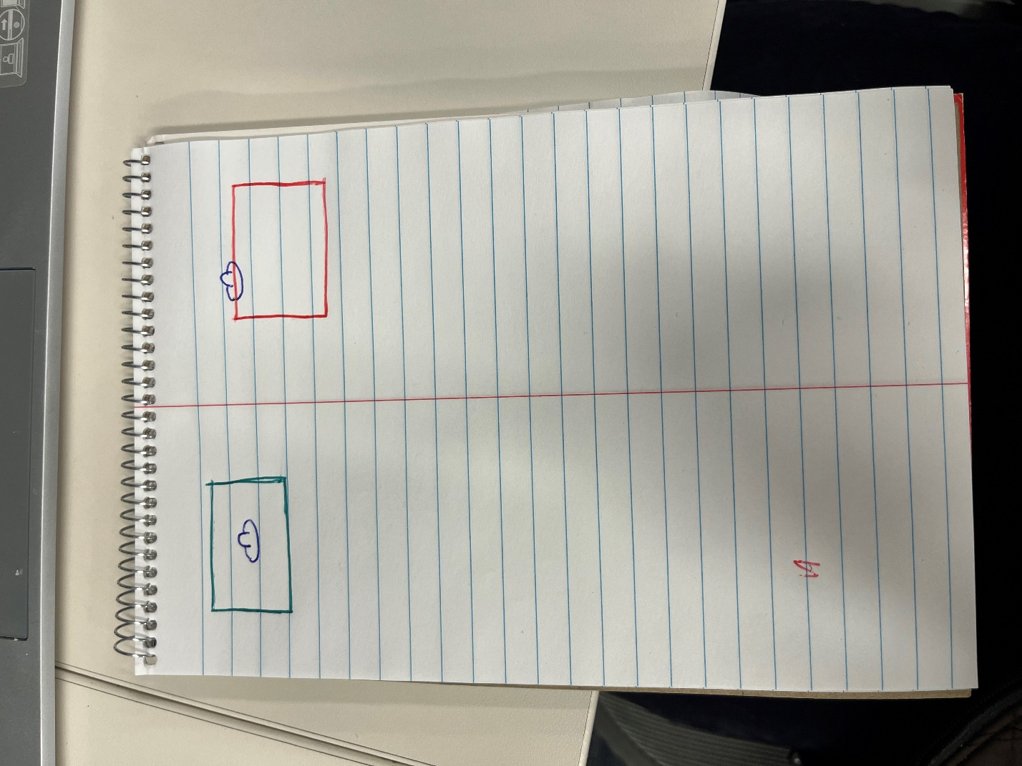
Theme: Alien Ships
The user’s POV will be in a cockpit that will move/ turn with head movement. There will be alien ships outside of the cockpit. The alien ships will be moving in the background. One at a time, a new alien ship will come into close proximity with the user’s location. The close proximity alien ship will have a “health bar” above it – alien ships can spawn with 2-5 health bars, I don’t think the order or anything like that matters as it is strictly contextual. The user’s POV/ vessel will be equipped with cannons on either side, like Jonathan’s VOR environment. The cannons and cockpit will move with the user’s head movements. Additionally, the background should be similar to the aforementioned VR demonstration videos: dark and spacelike but with large still reference points to avoid cybersickness.
Response selection will cause several animations. When the response selection (left/ right buttons) is correct, the respective cannon (left/ right) will fire at the alien ship. For example, if the correct response is to click right and the user clicks right, the cannon on the right side of their ship will fire at the alien ship, causing an explosion on impact of the alien ship, and for the arrow objects to disappear If you want to make a disappearing animation of some kind for the arrow objects that’s cool, but it should be clearly different than the arrow objects exploding and hitting your ship (see next sentences). If the response selection is incorrect, the arrow objects will continue to move towards the user and explode like they are hitting you/ your ship. The same thing should happen if the user does not respond quick enough.
After the explosion animation on the alien ship after a correct hit, the alien ship should lose a life on it’s health bar. When all lives are depleted, the alien ship will simply not survive the explosion animation after being hit. After the animation that destroys the alien ship, another one will “spawn” from the background.
Game Completion
For now, let’s make it so that users have to respond to 50 Flankscape stimuli (50 sets of arrow objects) to complete the game, so that no more alien ships appear.

